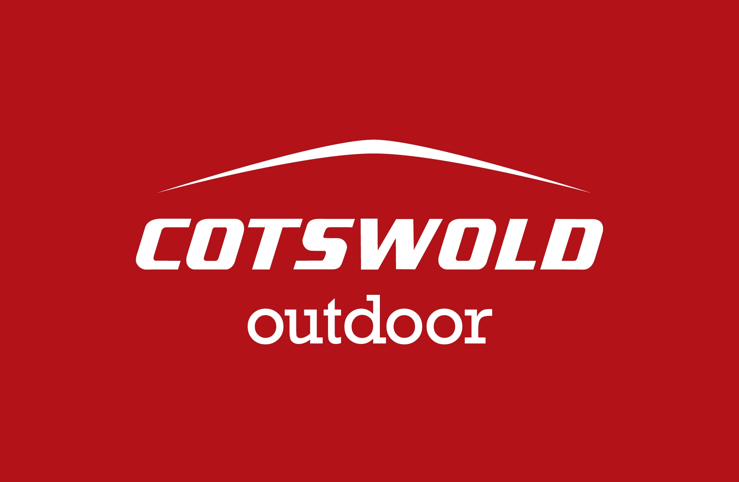

Cotswold Outdoor Limited
Unit 11. Kemble Business Park
Crudwell
Nr. Malmesbury
Wiltshire

SN16 9SH

Tel. 01666 575500
www.cotswoldoutdoor.com
groupsales@cotswoldourdoor.com

Monday 15th June 2015

Dear Paul,

Thank you for your email regarding your expedition to Mt. Everest. Cotswold Outdoor receives a significant number of sponsorship and support requests throughout the year (as you can imagine) and we cannot hope to support even a fraction of them. Being a relatively small company we don’t have a sponsorship/donation program and have a limited budget for this type of activity which we have already designated to aid Oxfam in the Nepal crisis.

While we cannot support everyone, we would like to help as best we can by offering you a 15% discount off all non-sale/non-offer products which we hope will help you prepare for your challenge. Please use the code AF-CFH-K2 when shopping online, in store or over the phone.

The barcode below on this letter can be scanned to activate the discount in store.

With regards to other support, I am afraid to say I cannot offer you anything in terms of products or financial aid.



Kind Regards,

The Group Sales Team

